

Shetland Islands Council

Schools Improvement Framework Appendix 1

School Improvement Planning and Standards and Quality Reporting

Operational Guidance

2017-2018

Contents

- Self-Evaluation for Self-Improvement 3
- The National Improvement Framework 7
- The Improvement Planning Cycle 10
- Revised Statutory Guidance: Standards in Scotland’s Schools etc. Act 2000 10
- School Improvement Plans 11
- Standards and Quality Reports 12

Appendices

Appendix A: Template for School Improvement Plan
Appendix B: Template for Standards and Quality Report
Appendix C: Driving Excellence and Equity: Education Scotland Advice on School Improvement Planning 2017/18
Appendix D: Driving Excellence and Equity: School Improvement Planning within the National Improvement Framework
Appendix E: Scottish Attainment Challenge: Pupil Equity Funding – Operational Guidance
Appendix F: Shetland Islands Council Pupil Equity Funding Local Guidance
Appendix G: Shetland Islands Council Pupil Equity Funding School / Cluster Plan

- Self-Evaluation for Self-Improvement

All schools will carry out a range of self-evaluation over the session to inform the following year’s development priorities.

The documents listed below are extremely useful for the purposes of self-evaluation. The first two, and other important resources, are available on the National Improvement Hub (https://education.gov.scot/improvement).

- ‘How good is our school?’ 4th Edition (2015)
- ‘How good is our early learning and childcare?’ (2016)
- Inspection Advice Note
- Scottish College for Educational Leadership (SCEL) website
- My GTCS website

Three questions are at the heart of self-evaluation:

- How are we doing?
- How do we know?
- What are we going to do now?

To help answer these questions, schools engage in a continuous process of looking inwards, outwards and forwards with proportionate self-evaluation where appropriate and overarching aim of achieving excellence and equity for all learners.

(Source: ‘How good is our school?’ (4th Edition), p. 9)

a) Looking inwards

For self-evaluation to be effective, it should start with those working directly with children and young people and be embedded in their day-to-day work. Staff teams, with partners, at a range of levels within and beyond the school, should engage in collaborative self-evaluation focusing on the impact on outcomes for learners. Self-Evaluation incorporates the professional dialogue and collaboration between teachers in schools, including peer observations and Teaching Learning Communities. Head Teachers have a crucial role in ensuring that schools have robust approaches to self-evaluation, ensuring all stakeholders are involved, and that time is built in to enable it to happen.

Pupils and parents should be actively involved in school self-evaluation, which may include a role for the school’s pupil and parent councils. Ultimately, it is good practice to include on school improvement plans a target, or area of development, that has been identified and subsequently to be led by pupils in the school, for example, through the pupil council. Some schools are also including an area for development by, and agreed with, their Parent Council.

“Effective, ongoing self-evaluation provides a unique and valuable picture of what is having most and least impact on learners in a single class, at a stage, within a school or across a cluster or local authority. It should take place within an aspirational vision for continuous school improvement where all stakeholders consider, ‘How good can we be?’ Once the quality of the impact on learners has been evaluated, then plans for improvement can be drawn up.”

(‘How good is our school?’ (4th Edition), p. 10)

Effective self-evaluation uses triangulation to ensure that decisions about improvement targets are based on robust evidence.

“The triangulation of quantitative data, people’s views, and direct observation of practice, should involve all school staff, learners, partners and other stakeholders. This process leads to a shared assessment of risk and an understanding of a school’s capacity for continuous improvement.”

(‘How good is our school?’ (4th Edition), p. 11)

QUANTITATIVE DATA  Quantitative data include for example data about attainment, attendance, bullying, prejudice-based discrimination and option  EVALUATION OF QUALITY  choices. Effective self-  evaluation includes rigorous interrogation of this  data by  staff who are data-literate  and use the data to  recognise emerging  issues and when  interventions are  necessary. | PEOPLE’S VIEWS  Staff, pupils, parents/carers, partners and stakeholders including the  local authority should all have  regular opportunities to share  their views about the school.  Examples of how people’s  views can be gathered  include through surveys,  focus groups, on-going  professional dialogue,  learning visits, and  minutes of team  meetings.
DIRECT OBSERVATION

Direct observation of practice can take place in a range
of learning contexts including during learning which takes
place outdoors, in a workplace, at college and during
excursions and residential experiences. Observations should
be linked to agreed criteria and a shared understanding of
their purpose. All stakeholders including staff, pupils,
parents and partners can engage in these structured
observations and give feedback to support self-evaluation
(‘How good is our school?’ (4th Edition), p. 11)

b) Looking outwards

In an effective culture of self-improvement, staff expect to look to others for new ideas that challenge their practice and support continuous improvement. Schools and teachers should learn from what works, and does not work, elsewhere. This includes finding out about practice in other parts of the same school, practice in other schools, working in learning communities, and learning from educational research.

Schools should make use of a wide range of sources, including the National Improvement Hub, to identify examples of good practice nationally as well as locally. Valuable international perspective can also be gained through research, and through Shetland schools’ partnerships and exchanges with schools in various countries, including the Global Classroom.

Good practice found elsewhere will not always be transposable directly into a different context. In the spirit of Curriculum for Excellence, practitioners and schools should reflect critically on how to adapt good practice found elsewhere to their own pupils’ needs.

‘How good is our school?’ (4th Edition) notes that external partners can give an objective view that complements schools’ self-evaluation. This may be especially helpful in small schools, but it is equally valid for all schools.
“Developing more specific self-evaluation questions and identifying relevant partners can ... help you identify aspects of school life which need a greater focus through individual professional development or collegiate working. Similarly, partners can develop their own bespoke self-evaluation toolkit by bringing together quality indicators or themes from different self-evaluation frameworks.”

(‘How good is our school?’ (4th Edition), p. 12)

To help effective school improvement, Shetland Islands Council supports collaborative working across the authority in identified school groups (for example clusters, or remote schools partnerships), Head Teachers’ Development Days, Subject Development Groups etc. Schools should also promote the effective sharing of good practice between staff within schools, and should actively seek out and nurture effective partnerships that support their work to raise attainment and achievement for all children and young people.

Finally, ‘How good is our school?’ (4th Edition) emphasises the value of collaborative action research projects as a means of increasing innovation and continuous improvement across classroom, school and local authority boundaries. ‘Such approaches go beyond simply sharing good practice. Collaborative enquiry brings depth to practitioners’ professional learning and leads to more accurate and honest self-evaluation.’ (‘How good is our school?’ (4th Edition), p. 10.

c) Looking forwards

Looking forwards helps schools to anticipate challenges and plan to meet the needs of young people in a rapidly changing world. It can provide the justification for moving things in a new direction.

It requires informed evaluation of likely developments and potential risks, and careful planning with the aim of bringing about sustainable improvement.

It also requires strong leadership at all levels, which is prepared to take risks and to be creative, and which encourages schools, staff and pupils to do the same.

d) Being Proportionate

Self-evaluation within the school can be universal but also targeted to key groups of learners, who may require greater support and more rapid interventions to improve their skills, wellbeing and performance in school.
e) Delivering Excellence and Equity for all our learners

It is strongly recommended to organise self-evaluation summaries under excellence and equity in line with the Scottish Government’s, Delivering Excellence and Equity in Scottish Education Plan, June 2016

What evidence do we have that our school demonstrate excellence for all our learners? | What evidence do we have that our school demonstrate equity for all our learners?

Overall, all self-evaluation should bring clarity and consistency to learning, teaching and assessment and lead to excellence and equity for all our learners.

- The National Improvement Framework (NIF)

The key priorities within the current National Improvement Framework (2016) are:

- Improvement in attainment, particularly in literacy and numeracy;
- Closing the attainment gap between the most and least disadvantaged children;
- Improvements in children and young people’s health and wellbeing;
- Improvements in employability skills and sustained, positive school leaver destinations for all young people.

It is now a requirement of every school in Scotland to have clear strategies in place to raise attainment in literacy and numeracy and close the poverty-related attainment gap. To support in this area, a Shetland Attainment Challenge Contact Group has been set-up, consisting of some head teachers; depute head teachers and central officers, working closely with Shetland’s Attainment Advisor to consider “closing the gap” within the local context.

Subsequently, a set of local vulnerability criteria has been identified that all schools may consider when identifying their own attainment gaps and considering strategies to close them. Refer to Circular 032/2016/I for more information.

The National Improvement Framework also sets out six key drivers for improvement, against which schools are expected to evaluate their progress in the improvement planning process.

The following table matches five of these six drivers for improvement to the most relevant quality indicators in ‘How good is our school?’ (4th Edition) (Education Scotland, 2015). Highlighted quality indicators are part of the reporting arrangements for the National Improvement Framework from 2016/17 onwards, through self-evaluation and school inspection.
NIF key driver for Improvement | Evidence this will provide | Supporting Quality  Indicators (‘How good is our school?’ 4th Edition)
School leadership | Quality and impact of  leadership at all levels within  the school | 1.3 Leadership of change  1.2 Leadership of learning
Teacher professionalism | Impact of collegiate working  and teacher professional  learning on children’s progress and achievement.  Effectiveness of moderation of teacher professional judgement of Curriculum for Excellence levels. | 2.3 Learning, teaching and assessment
Parental engagement | Impact of parents and parent councils in helping the school  to improve.  Ways in which parents are  partners in their child’s  education.  Progress towards developing a family learning programme  across communities. | 2.5 Family  2.7 Partnerships
Assessment of children’s progress | Percentage of children  achieving Curriculum for  Excellence levels in reading,  writing, listening and talking  and numeracy at P1, P4, P7  and S3.  Children’s overall achievements in national  qualifications and trends in  improving attainment over  time. | 2.3 Learning, teaching and assessment  1.1 Self-evaluation for self-improvement  1.2 Leadership of learning
School improvement | Success in raising attainment  and achievement for all  children.  Extend to which the school  ensures equity for all children.  Overall quality of learning,  teaching and assessment  Overall progress with key  priorities at school, local and  national level | 2.3 Learning, teaching and assessment  3.2 Raising attainment and achievement  1.1 Self-evaluation for self-improvement  2.2 Curriculum  3.3 Increasing creativity and employability  2.4 Personalised support  2.6 Transitions

The sixth driver, ‘Performance Information’ involves gathering together and analysing all the data collected from each of the key drivers.

Data collected through these drivers will support schools and local authorities to address the following questions:

- Which ‘gaps’ exist in the school?
- How are they measured?
- How will they be reduced?
- How will the school know?

As well as the QI’s listed in the table, QI 3.1, Ensuring Wellbeing, Equality and Inclusion should also be referred to closely.

- The Improvement Planning Cycle

Each school’s Standards and Quality Report on the previous session, the draft School Improvement Plan for the new session and the Working Time Agreement must be submitted to the school’s Quality Improvement Officer by the end of September each year. Schools may wish to submit their School Improvement Plan and Standards and Quality Report as a single document. If so, they should adapt the templates in this document accordingly.

As set out in the LNCT Joint Secretaries Advice Note on Working Time Agreements, August 2016, a school’s Working Time Agreement and School Improvement Plan (SIP) are inter-dependant and should be developed annually. According to SNCT Handbook Appendix 2.18, WTAs should ‘inform the targets, time and resources in a School Improvement Plan.’

It may be appropriate for departments within secondary schools to follow a similar cycle, including their own improvement plans and standards and quality reports.

- Revised Statutory Guidance: Standards in Scotland’s Schools etc. Act 2000

Schools should refer to the guidance on plans and reports in the revised Standards in Schools etc. Act 2000 statutory guidance published on the 27 March 2017.

Section 4 of the guidance refers to planning and reporting duties for schools:
- "School development plans" are replaced by "school improvement plans" (SIPs) and must be produced on an annual basis, with the task being delegated from education authorities to individual Headteachers.
- The plans must be underpinned by consultation with:
- pupils;
- any Parent Council or Combined Parent Council established for the school;
- teachers employed in the school;
- any volunteers working in the school;
- local bodies representing teachers, volunteers and parents of pupils in attendance at the school.
- Education authorities are required to prepare annual SIPs and annual SIP reports (Standards and Quality reports). Section 8(2) (a) of the 2000 Act requires that the duty to prepare the SIP is delegated to headteachers of individual schools, and section 8(2) (b) allows for the delegation to headteachers of other management functions, which might include the duty to prepare the SIP report.
- The SIP must take account of the authority's annual plan (or revised plan) prepared under section 3F and annual report prepared under section 3H (which detail work in pursuance of the NIF, steps to be taken and taken to reduce inequalities of outcome and likely or demonstrated educational benefits for pupils resulting from such steps), and its strategy for parental involvement prepared under new section 2(4A) of the Scottish Schools (Parental Involvement) Act 2006 (as amended by section 6 of the 2016 Act). It should also set objectives for the school (including objectives as to the involvement of a pupil's parents in the education provided to the pupils and to the school's pupils generally) and it should contain a statement of the authority's ambitions for the school. Finally it should include a summary of the SIP.
- The SIP has to include an account of the ways in which, and extent to which, the headteacher of the school will consult the pupils in attendance at the school and seek to involve them when decisions require to be made concerning the everyday running of the school.
- The SIP report must be prepared twelve months after publication of the SIP, without unreasonable delay, and must set out what was done during that period to implement the SIP.

- School Improvement Plans

The Education (Scotland) Act 2016 requires each School Improvement Plan, starting in 2017, to set objectives that take account of the Schools and Quality Improvement Service Annual Service Plan. As referred to in Section 2 of this Appendix, these must include steps to close the attainment gap between the most and least disadvantaged children, and to meet the other priorities in the National Improvement Framework including raising attainment in literacy and numeracy.

To support schools in this area and as part of the Scottish Government’s Excellence and Equity Delivery Plan, Education Scotland issued advice on school improvement planning in relation to the National Improvement Framework priorities and drivers in December 2016 with a supplementary poster issued in February 2017. Links to these papers are included below and can also be found in appendices to this document.

https://education.gov.scot/improvement/Documents/NIFschoolimprovementguidance201718.pdf and https://education.gov.scot/improvement/nif1poster

As per the Education Scotland guidance, clear planning for how Pupil Equity Funding (if applicable) will be used to provide targeted interventions in literacy, numeracy and health and wellbeing to close the poverty related attainment gap must be referenced in School Improvement Plans.

Schools in receipt of this funding should devote one of their school improvement priorities to planning targeted interventions around Pupil Equity Funding. Local guidance on the use of Pupil Equity Funding and planning are included as additional appendices to this document.

School Improvement Plans must also include an account of the ways in which pupils will be consulted and involved in decisions about the running of the school, and their strategy for parental involvement.

The purpose of the School Improvement Plan is to manage change and improvements. All the actions in a School Improvement Plan should be designed to raise attainment and achievement for pupils. As well as national priorities, schools should take into account the Schools and Quality Improvement annual Service Plan. However, the School Improvement Plan should also address the schools’ own priorities identified through self-evaluation. Along with the Standards and Quality Report, the Improvement Plan is a pivotal document during Education Scotland inspections and local authority School Improvement or Team Improvement visits.

It is recommended that the School Improvement Plan refers to the template given in Appendix A. It should be clear and concise and contain no more than around four priorities, some of which may continue over a number of years. In short, Children’s Services strongly recommend a manageable number of priorities for schools. However, it is more than a list of tasks.

The ambition of the plan lies in schools clearly stating the desired improvements that actions should bring to pupils and the school community. These improvements should be observable and quantitative wherever possible, but intelligent accountability requires the use of a range of qualitative evidence as well.

Engagement of staff, pupils, parents and partners in the preparation of the School Improvement Plan should occur through a process of monitoring and review throughout the school year. This should ensure that everyone concerned shares ownership of the final plan.

The School Improvement Plan is a working document. It may be adapted in the course of the year, for example following a local authority School Improvement Visit, or to reflect unforeseen new priorities. Milestones in terms of making progress towards targets and priorities should be shared with all staff, pupils and parents. Alterations to the plan must be shared with the school’s Quality Improvement Officer.

- Standards and Quality Reports

The Standards in Scotland’s Schools Act (2000) requires every school to publish an annual report (usually called a ‘Standards and Quality Report’) on what was done to implement its previous School Improvement Plan.

Shetland Islands Council must, from 2017, produce an annual report on progress in the steps it has taken to close the attainment gap between the most and least disadvantaged children and to meet the other priorities in the National Improvement Framework. Part of each school’s Standards and Quality Report should do the same.

More specifically, evaluations of the impact of the school’s actions to improve excellence and equity, and achieve positive outcomes for all children and young people need to be clearly stipulated in the report. Outcomes and impact from the use of Pupil Equity Funding will also be included from 2018 onwards.

Strategies which have been successful in engaging children and young people, staff, parents and the wider community should also be highlighted within the report.

The Standards and Quality Report is the school’s high-level summary self-evaluation and is a crucial document in the school improvement cycle. Along with the School Improvement Plan, it is central to Education Scotland Inspections and local authority improvement visits.

Standards and Quality reports should use available data to provide an accurate and meaningful benchmark of progress and achievement for the school whilst avoiding the identification of individual pupils. Data may include:

- Relevant areas of Insight including National Benchmarking measures, local measures and virtual comparator schools
- SEEMIS vision reports
- Annual Teacher Judgement Survey Results for Reading, Writing, Listening and Talking and Numeracy at Early Level, First Level, Second Level and Third Level.

The Standards and Quality Report should refer closely to the template outlined in Appendix B. It should be structured around the priorities in the National Improvement Framework, stated in Section 2 of this operational guidance paper.

Moreover, three high-level questions should be considered:

- How well do pupils learn and achieve?
- How well is the school helping pupils to develop and learn?
- How well is the school improving the quality of its work?

It should be clear and concise and written for distribution to parents. It should contain factual performance information and evaluative statements. Schools will use the ‘key areas of development’ identified in their Standards and Quality Report as the basis for their new School Improvement Plan.

The Standards and Quality Report should be based on rigorous self-evaluation, focusing on outcomes for learners. It requires continuous collation and analysis of evidence including quantitative data, observations, discussions, and consultations with pupils, parents and carers, and other partners.

Self-evaluation is the responsibility of every individual who works with young people in schools. Staff teams, with partners, at all levels within and beyond the school, should also engage in collaborative self-evaluation. Head teachers have a crucial role in ensuring that schools have robust approaches to self-evaluation and that time is built in to enable it to happen.

The documents listed below are extremely useful for the purposes of self-evaluation. The first two, and other important resources, are available on the National Improvement Hub (https://education.gov.scot/improvement).

- ‘How good is our school?’ 4th Edition (2015)
- ‘How good is our early learning and childcare?’ (2016)
- Inspection Advice Note 2016-17
- Scottish College for Educational Leadership (SCEL) website
- GTCS website
APPENDIX A

XXXX School

School Improvement Plan

Session XXXX

Factors Influencing the Improvement Plan

School factors
Insert only those which are particular to your school this may include significant recent changes in the school.

Local authority factors
- Schools and Quality Improvement Service Plan

National factors
For example:

- National Improvement Framework
- Curriculum for Excellence
- Getting it Right for Every child (GIRFEC)
- Education (Scotland) Act 2016
- How Good Is Our School (4th Edition)

School Aims
Insert

How pupils were consulted and involved in decisions

Strategy for parental engagement

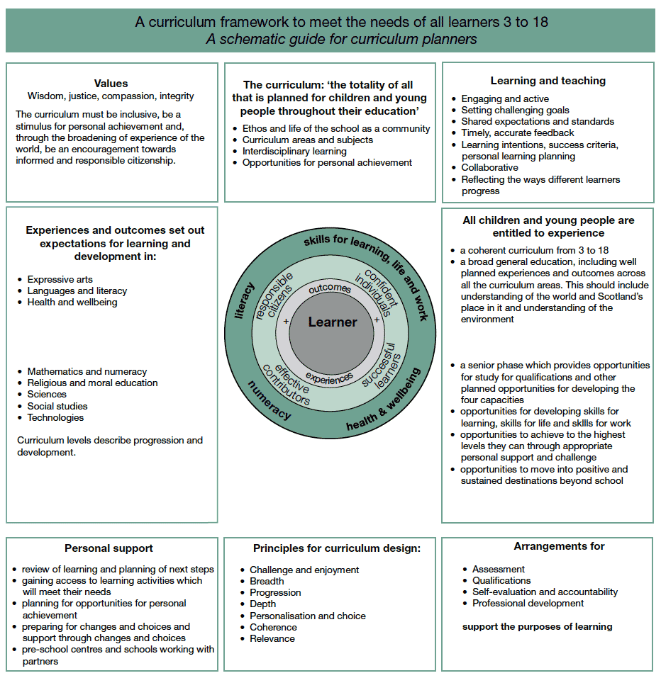
You may wish to replace this page with your own curriculum map.

Optional Three Year Strategic Curriculum Plan
Session | Area for Development  The text entered below should be the same as that used at the end of your Standards and Quality Report for the session ending, and in the School Improvement Plan Areas for Development. | Desired Outcomes
xxxx
xxxx
xxxx

Priority 1 with link to relevant NIF Priority Target and /or Driver(s) as well as appropriate Quality Indicator(s):
Target:
School’s current position:
Desired Outcomes  .  These should be expressed in terms of impact on pupils. | Implementation Process (Actions) | By whom  Use positions or group titles. Do not use people’s names. | Time Scale  Be specific. Do not use “on-going”. | Resources  Any costs inserted here should be major spends such as equipment or training input. | Monitoring  This should state how and by whom and may relate to particular desired outcomes or individual actions.
Evaluation:  Write key questions to be used at planned review times during the session. These should be used by learners, staff and partners to evaluate progress towards meeting the desired outcomes. This will help you to write in evaluative language and will be used to inform your next Standards and Quality Report. |  |  | Evidence (How do we know?)  List the key sources of evidence.

Additional Tasks xxxx  Insert any tasks which are noted as areas requiring development within your Standards and Quality report for the session ending and which are not included in the key areas for development above. Each task should have a brief action plan (these are for internal school use only). | Responsibilities

APPENDIX B

XXXX School

Standards & Quality Report

Session XXXX

Introduction

Shetland Islands Council is committed to delivering the best possible outcomes for children and young people so that they have the best start in life and are ready to succeed by following the principles of Curriculum for Excellence and Getting it Right for Every Child (GIRFEC).
Within Curriculum for Excellence, every child and young person is entitled to experience a curriculum which is coherent from 3-18. Those planning the curriculum have a responsibility to work in partnership with others to enable children and young people to make transitions smoothly, building on prior learning and achievement in a manner appropriate to their individual learning needs. This should ensure that young people are well placed to move to positive destinations on leaving school and entering adult life.
We want to know how well we are doing this and how we can improve. We are continuously evaluating what we do and how it makes a difference to our learners. We have been asking ourselves – staff, pupils, parents/carers, and other partners – the questions contained in this Standards and Quality Report. Our self-evaluation is in the pages that follow, along with our main areas for development for session XXXX. This report is based on the quality indicators in How Good is Our School? 4th Edition (2015) and How Good is our Early Learning and Childcare? (2016)

Progress in the areas we developed in our XXXX School Improvement Plan is outlined in the Appendix.

Context of the School

This section should contain relevant information related to school factors influencing the School Improvement Plan.

The three key questions to address within the Standards and Quality Report are:
- How well do pupils learn and achieve?
- How well is the school helping pupils to develop and learn?
- How well is the school improving the quality of its work?

When answering these three questions, please refer closely to the National Improvement Framework priorities and drivers including evaluations of pupil equity funding projects and interventions, referring to pages 8 and 9 of this Appendix for more information about the drivers.

The current National Improvement Priorities are:

- Improvement in attainment, particularly in literacy and numeracy;
- Closing the attainment gap between the most and least disadvantaged children;
- Improvement in children and young people’s health and wellbeing; and
- Improvement in employability skills and sustained, positive school leaver destinations for all young people

The National Improvement Drivers are:

How well do pupils learn and achieve?
(Q.I. 2.3 Learning, teaching & assessment; 3.1 Ensuring wellbeing, equity and inclusion; 3.2 Raising attainment & achievement)

Insert an overarching high level evaluative statement.

Strengths

Areas for Development
These should be high level overarching outcomes and not a list of tasks.
To be written as bullet points

How well is the school helping pupils to develop and learn?
(Q.I. 1.2 Leadership of learning; 2.2 Curriculum; 2.4 Personalised support; 2.5 Family Learning; 2.7 Partnerships; 3.1 Ensuring wellbeing, equity and inclusion

Insert an overarching high level evaluative statement.
Strengths

Areas for Development
These should be high level overarching outcomes and not a list of tasks.
To be written as bullet points

How well is the school improving the quality of its work?
(Q.I. 1.1 Self-evaluation for self-improvement; 1.3 Leadership of change)

Insert an overarching high level evaluative statement.
Strengths

Areas for Development
These should be high level overarching outcomes and not a list of tasks.
To be written as bullet points

Improvement Priority 1: XXXX (referring to the new School Improvement Plan if it is a separate document)
Our key areas for development to take this priority forward are:
Target: Use the same wording as in your new School Improvement Plan.

Improvement Priority 2: XXXX (referring to the new School Improvement Plan if it is a separate document)
Our key areas for development to take this priority forward are:
Target: Use the same wording as in your new School Improvement Plan.

Improvement Priority 3: XXXX (referring to the new School Improvement Plan if it is a separate document)

Our key areas for development to take this priority forward are:
Target: Use the same wording as in your new School Improvement Plan.

Standards and Quality Report: Appendix

Progress made with the areas for development in our School Improvement Plan Session XXXX (The Previous Session’s School Improvement Plan)

Improvement Priority 1: XXXX
Target: Use the same wording as in your previous School Improvement Plan.

Insert an overarching high-level evaluative statement, e.g. Very good progress was made in this area.
Evidence indicated: To be written as bullet points

Further Work required (if any): To be written as bullet points

Improvement Priority 2: XXXX
Target: Use the same wording as in your previous School Improvement Plan.

Insert an overarching high-level evaluative statement e.g. Very good progress was made in this area.
Evidence indicated: To be written as bullet points

Further Work required (if any): To be written as bullet points

Overall evaluation of the school’s capacity for continuous improvement:

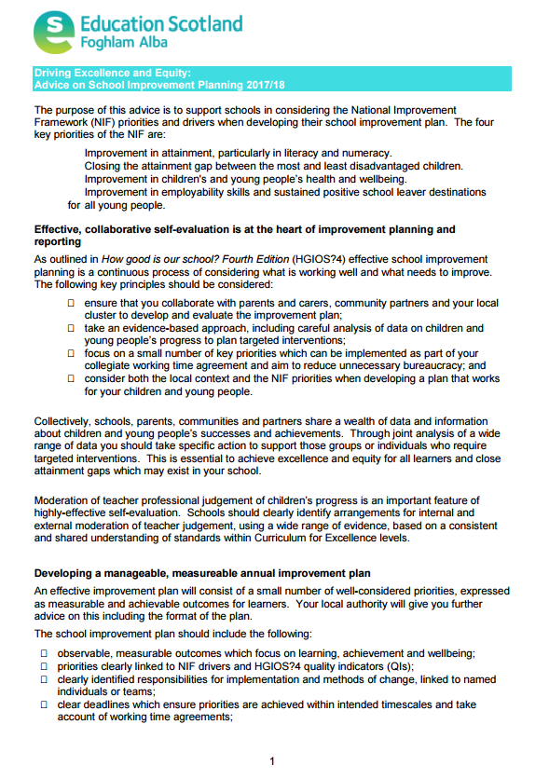
APPENDIX C: Driving Excellence and Equity: Education Scotland Advice on School Improvement Planning 2017/18
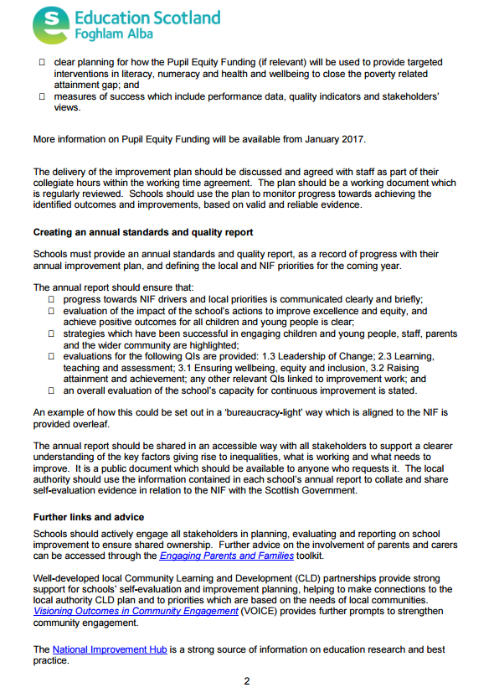
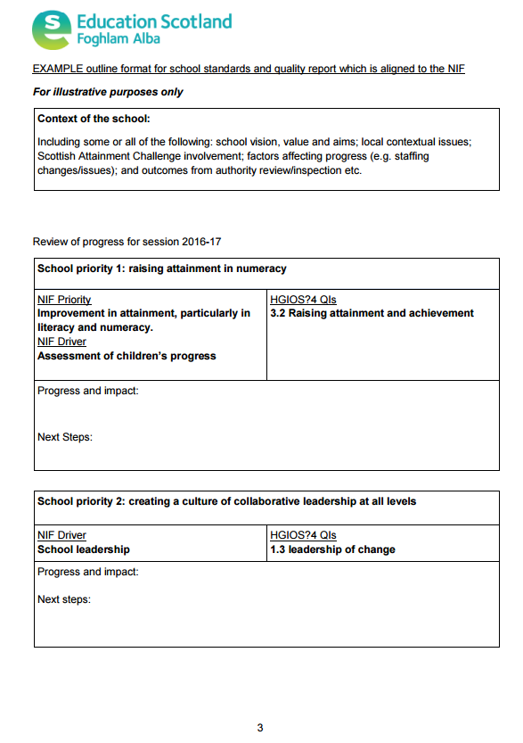
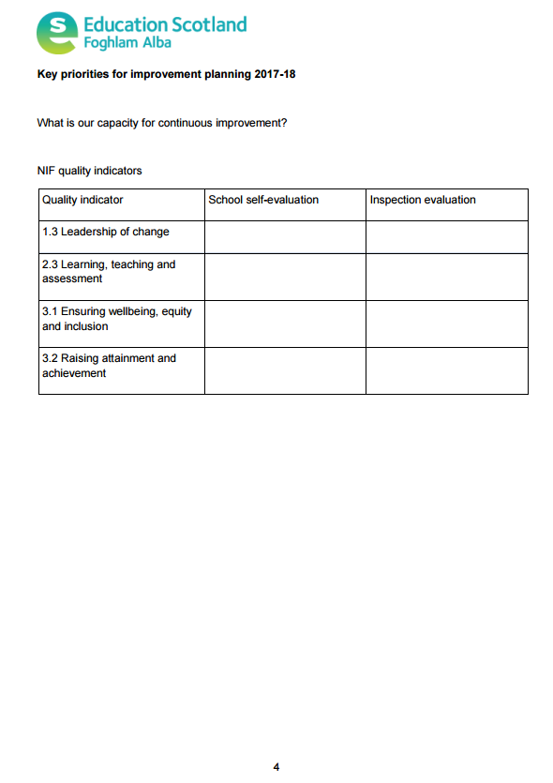
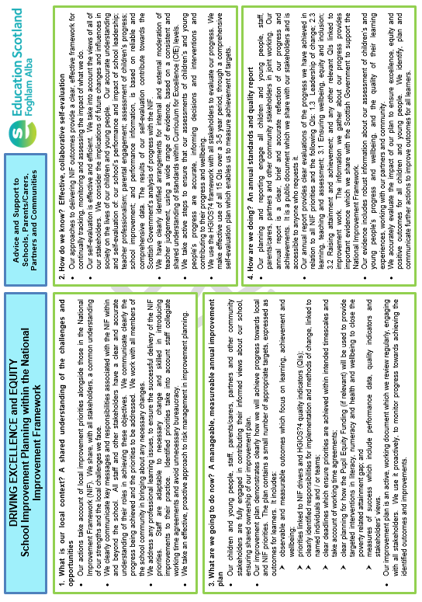
APPENDIX D: Driving Excellence and Equity: School Improvement Planning within the National Improvement Framework
APPENDIX E: Scottish Attainment Challenge: Pupil Equity Funding – Operational Guidance

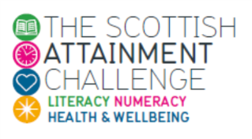
Pupil Equity Funding – National Operational Guidance - 2017
What is it?
The Pupil Equity Funding is additional funding allocated directly to schools and targeted at closing the poverty related attainment gap. The Scottish Government has committed to this funding as part of the Scottish Attainment Challenge programme from 2017-18. The Pupil Equity Funding forms part of the £750m Attainment Scotland Fund which will be invested over the current Parliamentary term.
This national guidance is intended to help schools plan how they will most effectively invest their Pupil Equity Funding allocation to improve the educational outcomes of children affected by poverty. Local authorities will issue complementary guidance about how the funding will operate locally.
Key Principles
- Headteachers must have access to the full amount of the allocated Pupil Equity Funding.
- The Pupil Equity Funding must enable schools to deliver activities, interventions or resources which are clearly additional to those which were already planned.
- Headteachers should work in partnership with each other, and their local authority, to agree the use of the funding. Schools must take account of the statutory responsibilities of the authority to deliver educational improvement, secure Best Value, and the authority’s role as employer. Local Guidance will set out more detail on how this will operate.
- The operation of the Pupil Equity Funding should articulate as closely to existing planning and reporting procedures as possible – e.g. through School Improvement Planning and Standards and Qualities reports.
- Parents and carers, children and young people and other key stakeholders should be involved in the planning process.
- Funding must provide targeted support for children and young people affected by poverty to achieve their full potential. Although the Pupil Equity Funding is allocated on the basis of free school meal eligibility, Headteachers can use their professional judgement to bring additional children in to the targeted interventions.
- Headteachers must develop a clear rationale for use of the funding, based on a clear contextual analysis which identifies the poverty related attainment gap in their schools and plans must be grounded in evidence of what is known to be effective at raising attainment for children affected by poverty.
- Schools must have plans in place at the outset to evaluate the impact of the funding.

How much is it?
Publicly funded primary, secondary and special schools will receive £1,200 in 2017-18 for each child in Primary 1 to S3, or equivalent, who is registered for free school meals under national eligibility criteria.
How is it allocated?
Pupil Equity Funding will be allocated to schools on the basis of the estimated number of children and young people in P1-S3 registered for free school meals under the national eligibility criteria.
In 2017/18 the funding allocation will be calculated using the most recently available Healthy Living Survey and Pupil Census data and will be based on:
- The estimated number of P1-P3 pupils who would be registered for free school meals using the national eligibility criteria. This will be done by taking the figures for 2014/15 and then applying those to the 2016 school rolls for P1 to P3.
- The estimated number of P4-P7 and S1-3 pupils who are registered for free school meals.
- The estimated number of special school pupils in the P1-S3 age range registered for free school meals.

The approach to estimating free school meal registrations will be kept under review as the Government seeks to improve the quality of data for identifying children living in households affected by poverty.
Funding for 2017/18 will be paid by the Government to local authorities by means of ring-fenced grant which will clearly indicate the amounts that should be allocated directly to each school. Local authorities will confirm arrangements for draw down at school level.

How can it be used?
Although the funding is allocated to schools on the basis of free school meal eligibility, Headteachers have discretion to make decisions about which children and young people would benefit most from any particular intervention, whilst keeping a clear focus on delivering equity. Funding should not be used in ways that stigmatises children and young people or their parents. Interventions that impact on transitions between school stages – for example between nursery and primary or between broad general education and senior phase – can also be considered.
The funding should be focused on activities and interventions that will lead to improvements in literacy, numeracy and health and wellbeing. Leadership; learning & teaching; and families and communities are useful organisers to consider when determining interventions..
A framework, ‘Interventions for Equity,’ has been developed to support the planning and implementing of interventions to meet the needs of children and young people affected by poverty in order to close the attainment gap. The examples cited act as a stimulus for wider reflection of what would suit your local context and are by no means the only interventions that should be considered.
Headteachers can work at an individual school and local community level or collegiately in wider school clusters and beyond at local authority level to address common interests. Interventions should be considered within the context of the school planning cycle and must be targeted towards closing the poverty related attainment gap. Where appropriate, funding should articulate with existing Scottish Attainment Challenge School and Challenge Authority improvement plans.
Evidence shows that some children and young people from equalities groups can be disproportionately affected by deprivation and can therefore face significant additional barriers to learning. Education authorities have responsibilities to actively address inequality and the promotion of equity is a shared responsibility held by all staff, partners and stakeholders. In this context, headteachers should consider additional steps that might be required to close the educational attainment gap for pupils affected by poverty who may also experience disadvantage for other reasons. For example, disadvantage related to; a protected characteristic (disability, gender reassignment, pregnancy and maternity, race, religion or belief, sex (gender) and sexual orientation); a need for which they require additional support; being looked after; having caring responsibilities.

Headteachers will need to be familiar with local policies and procedures – such as the Local Code of Corporate Governance, Local Schemes of Delegation, the Role of the Section 95 officer, the local Devolved School Management policy and local school planning cycle – the local operational guidance which may issue alongside this national guidance should contain more information about these local policies.
Partnerships
Parents and the local community are a valuable source of support and partnership. In many contexts schools may be able to achieve the best possible outcomes for children and young people by working with a range of bodies such as parent groups; parent councils; other local authority and public sector services; third sector organisations (including youth work, family learning organisations); other educational sectors; and/or centres of expertise. Understanding the needs of children and young people should help to identify appropriate areas for collaboration.
Staffing
Where schools identify the need to recruit additional staff for an appropriate intervention or activity, they should work closely with the Local Authority (as the employer) to ensure that the job remits and specifications are clearly tied to the aims of the intervention. Headteachers need to take full account of local HR policies and procedures and that staffing costs include not just salaries but also on-costs such as pensions, sick leave, maternity cover and also potentially recruitment costs. Local guidance should provide further clear details of these costs. Any teachers recruited through Pupil Equity Funding will be excluded from the authority’s contribution to any national teacher numbers and / or ratio commitment, which means it is essential to fill core staffing posts first before recruiting additional teachers.

Procurement
Purchase of resources, equipment or services must comply with existing local authority procurement procedures. This will be particularly important when buying ICT resources (see below) or, for example, services from third sector partners. Schools should liaise with their relevant local authority finance partners to ensure compliance with procurement policies and legislation.
ICT
The Pupil Equity Funding can be used to procure digital technologies, including hardware and software, when its allocation and use is particularly focused on supporting children and young people affected by poverty to achieve their full potential. The Scottish Government provides access to a range of national procurement frameworks for the purchase of digital technology products and devices, including a range of desktops, laptops and tablets. The frameworks offer a direct route to market and significant savings against RRP.
To prevent issues arising with compatibility and connectivity, schools seeking to purchase digital technology should do so in close consultation with the IT Department at their local authority.

We know that simply providing more technology does not result in improved outcomes for learners. Therefore, any deployment of technology in an educational setting should be undertaken in line with the objectives of the national Digital Learning and Teaching Strategy.

Support
There is a package of support available to assist schools in planning how to use their Pupil Equity Funding. This includes:
- A framework of evidenced and proven educational interventions and strategies to help tackle the poverty related attainment gap. The framework can be used by all partners and should help to inform the decisions schools make. The structure and content will be dynamic and will continue to evolve as an integral part of the National Improvement Hub, where a wide range of improvement, self-evaluation and research materials are available and where practice exemplars can be shared. Other research summaries and intervention examples will be incorporated as these become available.
- This suite of materials will be developed further in the coming months as the Scottish Government works with the Education Endowment Foundation to develop a Scottish specific version of their Teaching and Learning toolkit.
- Attainment Advisors who will be able to provide advice on a regional basis.
- A dedicated Scottish Attainment Challenge community on Glow where all educators can have online discussions, ask questions, post responses, exchange ideas, access additional resource materials and share examples of practice. In addition, this secure community will be used to host regular discussions about the interventions and strategies being developed through the Pupil Equity Funding.
- Access to collaboration and communication tools on Glow including Yammer, Sharepoint, Blogs and Glow TV. These tools provide great opportunities for joint working and for sharing materials across all involved in the Scottish Attainment Challenge, with the ability to control visibility where required.
- Guidance on School Improvement Planning, including Standards and Quality reporting through the National Improvement Framework.
- We will continue to explore what other events and national support can be provided during the coming year.

Local authorities will also offer their own packages of support for schools to help them plan how to use the funding effectively.

Outcomes, impact and measurement
At a school level, it is essential that headteachers continue to make best use of the data they have access to locally to understand which children and young people would benefit from targeted support and to monitor and track learners’ progress over time. Further guidance on the BGE assessment model was issued in November 2016. Progress towards closing the attainment gap will be reported in the annual national and local National Improvement Framework evidence reports.

Accountability and reporting
The Headteacher will be accountable to their local authority for the use of Pupil Equity Funding within their school. To ensure transparency, schools will be expected to incorporate details of their Pupil Equity Funding plans into existing reporting processes to their Parent Council and Forum, including in their annual School Improvement Plans and Standards and Quality Reports. These reports should be publicly available so that parents can understand what is happening in their school. The arrangements for publication will be confirmed by your local authority.
School inspection and other review processes will be used where necessary to ensure schools use their funding appropriately. ‘How Good Is Our School? 4’ includes an evaluation on the six point scale of the school’s success in raising attainment and achievement and ways in which they can demonstrate improvements to equity for all learners. In addition, the operation, use and effectiveness of the Pupil Equity Funding at closing the poverty related attainment gap at a local authority level will feed into other existing quality assurance processes, such as Audit Scotland’s Shared Risk Assessment.
Unspent funds
Where schools are unable to spend their full allocation during the financial year, any underspent grant may be carried forward to the next financial year though it would be expected that it would normally be spent within the school year. Schools will need to liaise closely with their local authority to agree arrangements for carrying forward Pupil Equity Funding, which should be considered separately from other funding within the devolved school management budget.
Scottish Government
March 2017

APPENDIX F: Shetland Islands Council Pupil Equity Funding Local Guidance

SHETLAND ISLANDS COUNCIL
Children’s Services Department
PUPIL EQUITY FUNDING: LOCAL GUIDANCE
Introduction
Nationally, £120 million has been provided to help raise attainment with a focus on supporting those children and young people who face barriers to their learning due to the impact of poverty. The funding is called Pupil Equity Funding (PEF).

PEF has been allocated based on the numbers of children and young people from P1 to S3 receiving free school meals in each primary, secondary and special school in Scotland. The funding is available for the financial year 2017/18 and is expected to be available each year for the lifetime of the current parliament. It should be noted sums received in 2017/18 are likely to change as the number of children receiving free school meals may change.

Planning for Improvement (PEF)

In their plan, schools, with the support of colleagues/partners, should identify the issue to be addressed, and the target group (or groups) of pupils most in need of additional support, based on an analysis of local evidence and data. Schools should ensure that they focus on a small number of priorities to meet local and national priorities. This is likely to focus on literacy, numeracy or health and wellbeing. Funding should be utilised in a way which best meet pupils’ needs, based on an analysis of their local needs, and the current evidence base. Whilst a particular focus may overlap with other areas, there should be a clear rationale for why an approach has been arisen, with clear methodology to measure impact in this area.

Impact should be considered in terms of the desired outcomes for pupils and how progress towards these will be measured over time. ‘Pupil Equity Funding Plans’ should include consideration of how performance data will be collected and reported.

It is recommended that schools work in partnership with colleagues in their cluster to share good practice and build capacity. Other partnerships should also be considered, such as with local third sector partners to support family learning or health and wellbeing.

A template is provided which should be used to set out detail of the proposed plan using where appropriate the Interventions for Equity framework published by Scottish Government.
The Equity Framework can be found on the National Improvement Hub:
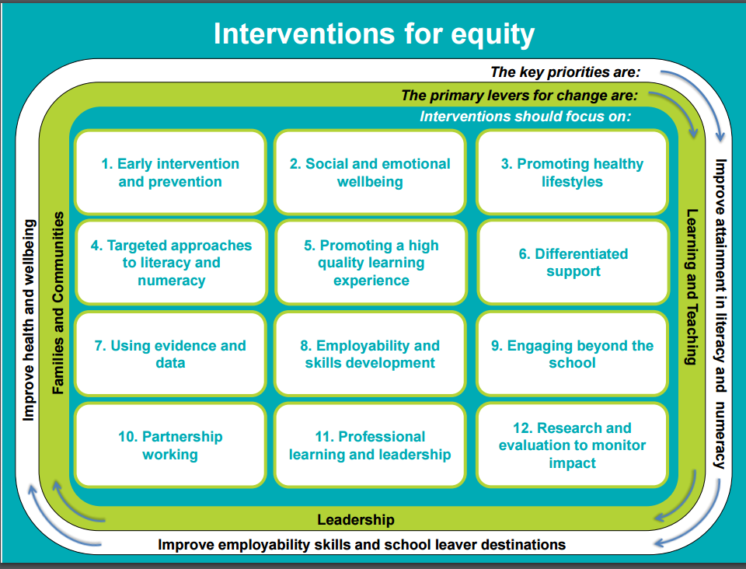
The link below gives access to a wide range of examples of interventions
https://education.gov.scot/improvement/Pages/Interventions-for-Equity.aspx

Key Principles
- Funding must enable schools to deliver activities, interventions or resources which are clearly additional to those which were already planned.
- Head Teachers should work in partnership with each other and the local authority to agree use of the funding.
- The operation of the PEF should articulate as closely to existing planning and reporting procedures.
- Parents, carers, children and young people and other key stakeholders should be involved in the planning process.
- Funding must be targeted to children and young people affected by poverty. Head Teachers can use their professional judgement to bring additional children into the targeted interventions.
- Head Teachers must base their use of funding on a clear contextual analysis which:
  - Identifies the poverty related attainment gap in their school; the local vulnerability criteria can be used to inform which children are affected;
  - Ensures plans are grounded in evidence of what is known to be effective at raising attainment.
- Schools must specify plans at the outset to evaluate the impact of the funding.

On this basis, all schools/clusters are expected to:

- Identify all children in their school affected by poverty and who are underperforming.
- Identify all children in their school who are underperforming due to circumstances unrelated to poverty.
- Identify baseline measures specific to the project in relation to Numeracy, Literacy and Health and Wellbeing for those children affected by poverty.
- Ensure interventions are based on proven methodology such as the Improvement Framework which will clearly evidence a positive impact. Funding will only be approved on the basis of a robust action plan being submitted which meets these criteria.
- All school and cluster project plans will submitted to the Quality Improvement Officer for the school, and will be shared with the Quality Improvement Team.
- All school and cluster plans will be compliant with the School Improvement Framework.
- All interventions must be grounded in evidence of what is known to be effective at raising attainment.
- Funding will only be released once a robust action plan has been submitted that meets these criteria, and is submitted on the attached Pro forma.

Accountability and Reporting

It is important to note that Head Teachers will be accountable to their local authority for the use of PEF within their school.

Next Steps
- Guidance and blank PEF project plan will be circulated.
- Attendance at Head Teachers’ briefing session on 13th March 2017.
- Schools which have elected to spend the funding on a school-only basis should discuss their proposal/plans with their QIOs.
- Schools which have elected to spend their funding on a cluster/partnership basis will meet to discuss their proposal/plans with their respective QIOs and Executive Manager QI.

Submission of Draft Plans by Schools/Clusters on Pro forma
- Consult on draft plan.
- Director to approve all draft plans.
- Funding approved and schools/clusters informed.
- Termly review at school or cluster level via regular QIO visits.
- Outcomes from use of PEF reported to Education and Families Committee.

APPENDIX G: Shetland Islands Council Pupil Equity Funding School / Cluster Plan

SHETLAND ISLANDS COUNCIL
Children’s Services Department

Pupil Equity Funding School/Cluster Plan

School/Cluster:

PEF: TOTAL FUNDING aLLOCATION:

Target Group(s)
Please specify stage(s) and numbers indicating criteria for selection. Attach as Appendix 1.

PROJECT TITLE:

STRETCH AIM
(Who? What? By how much? By when?)

PRIMARY DRIVERS
(Must include involvement of key stakeholders i.e. parents)

SECONDARY DRIVERS
(Key actions to be taken – including frequency, responsibility (who?), resources. These should relate to primary drivers)

PROJECT BASELINE DATA
(Please indicate what the baseline and outcome measurements will be – this must relate to the stretch aim)

OUTCOMES

MONITORING TIMELINE: TERMLY WITH QIO
(What and when)

RESOURCES AND COSTS
Items | Actual Cost(s)

heAD tEACHER SIGNATURE:
DATE:

http://www.gov.scot/Topics/Education/Schools/HLivi/schoolmeals/FreeSchoolMeals
https://education.gov.scot/improvement/Pages/Interventions-for-Equity-framework.aspx
www.gov.scot/Publications/2016/09/9494
https://education.gov.scot/improvement/Pages/Interventions-for-Equity-framework.aspx
https://education.gov.scot/improvement/Pages/Education-Endowment-Foundation.aspx
https://education.gov.scot/improvement/nif1poster
https://education.gov.scot/improvement/curriculum-for-excellence-benchmarks
https://education.gov.scot/improvement/Pages/frwk2hgios.aspx

